Relational Database Specification

**Table of Contents**

1.0 A Description of the Application Background 3

2.0 A Specification of the Database Requirements 3

3.0 The ER Diagram 5

4.0 The Relational Database Schema 6

5.0 The Sample Database (instance) 6

6.0 The SQL Statements 11

7.0 The Query/Update results 13

# 1 .0 A Description of the Application Background

#### The database system we have chosen is that of a simple local banking system such as TCF Bank with multiple branches, due to our familiarity with banking systems.The database will keep records of customer attributes, For our sample database banks have multiple Bankers working for them. Each banker is assigned to a single customer. Bankers can assign customers loans. Customers will be able to borrow loans, get credit cards. Bank branches have ATMs and bankers working for them.

# 2 .0 A Specification of the Database Requirements

Our Database is designed in MySQL Version 5.7.32. It will have tables of each entity

from the following ER Diagram. Each entity will have attributes with a primary key and may also have a foreign key to refer to different tables. Here are descriptions of each table:

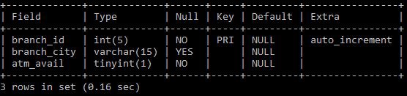Bank Table:

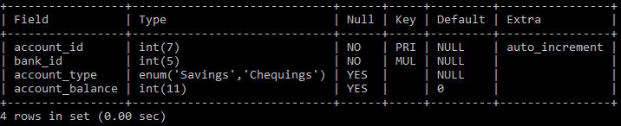Account Table:

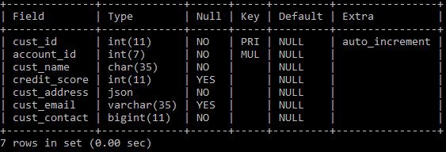Customer Table:

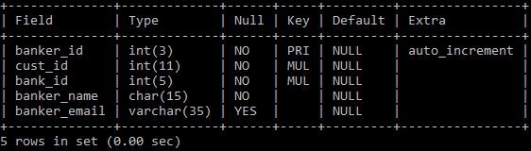Banker Table:

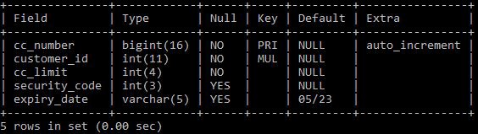Credit Card Table:

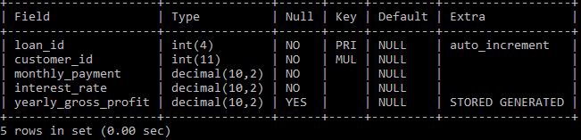Loan Table:

# 3 .0 The ER Diagram

# 4 .0 The Relational Database Schema

# 5 .0 The Sample Database (instance)

#[1]

INSERT INTO bank_tb(branch_city,atm_avail) VALUES('Troy',True); INSERT INTO account_tb(bank_id,account_type,account_balance) VALUES(1,'Savings',17823);

INSERT INTO

customer_tb(account_id,cust_name,credit_score,cust_address,cust_email,cust_contact) VALUES(2587495,'John King',790,'{"Street":"1234, Brook

Dr","City":"Troy","State":"MI","Zip":48089}',"[john121@gmail.com](mailto:john121@gmail.com)", 2482501234);

INSERT INTO banker_tb(cust_id,bank_id,banker_name,banker_email) VALUES(1,1,'Paul Toledo',"[paultol@gmail.com](mailto:paultol@gmail.com)");

INSERT INTO credit_card(customer_id,cc_limit,security_code) VALUES(1,2000,763);

INSERT INTO loan_tb(customer_id,monthly_payment,interest_rate) VALUES(1,170,3.2);

#[2]

INSERT INTO bank_tb(branch_city, atm_avail) VALUES('Detroit', False); INSERT INTO account_tb(bank_id,account_type,account_balance) VALUES(2,'Chequings', 5562);

INSERT INTO

customer_tb(account_id,cust_name,credit_score,cust_address,cust_email,cust_contact) VALUES(2587496,'Julie Nice',470,'{"Street":"463, Bonnie Ln","City":"Detroit","State":"MI","Zip":48128}',"[julnic101@yahoo.com](mailto:julnic101@yahoo.com)", 3133445632); INSERT INTO banker_tb(cust_id,bank_id,banker_name,banker_email) VALUES(2,2,'John Williams',"[jwill1009@outlook.com](mailto:jwill1009@outlook.com)");

INSERT INTO credit_card(customer_id,cc_limit,security_code) VALUES(2,5000,345); INSERT INTO loan_tb(customer_id,monthly_payment,interest_rate) VALUES(2,145,2.5);

#[3]

INSERT INTO bank_tb(branch_city, atm_avail) VALUES('Dearborn', True); INSERT INTO account_tb(bank_id,account_type,account_balance) VALUES(3,'Savings', 14567);

INSERT INTO

customer_tb(account_id,cust_name,credit_score,cust_address,cust_email,cust_contact) VALUES(2587497,'Manish Patel', 560,'{"Street":"789, Ford Road","City":"Dearborn","State":"MI","Zip":48126}',"[mannipa119@hotmail.com](mailto:mannipa119@hotmail.com)", 3135436756);

INSERT INTO banker_tb(cust_id,bank_id,banker_name,banker_email) VALUES(3,3,'Logan Lee',"[loglee@gmail.com](mailto:loglee@gmail.com)");

INSERT INTO credit_card(customer_id,cc_limit,security_code) VALUES(3,2500,129);

#[4]

INSERT INTO bank_tb(branch_city, atm_avail) VALUES('Rochester Hills', True); INSERT INTO account_tb(bank_id,account_type,account_balance) VALUES(4,'Chequings', 150950);

INSERT INTO

customer_tb(account_id,cust_name,credit_score,cust_address,cust_email,cust_contact) VALUES(2587498,'Jessica Paul', 670,'{"Street":"1239, Rochester Road","City":"Rochester Hills","State":"MI","Zip":48306}',"[jesspaul007@outlook.com](mailto:jesspaul007@outlook.com)", 2487653214);

INSERT INTO banker_tb(cust_id,bank_id,banker_name,banker_email)

VALUES(4,4,'Lucy Johnson',"[johnsonlucy11@yahoo.com](mailto:johnsonlucy11@yahoo.com)"); INSERT INTO loan_tb(customer_id,monthly_payment,interest_rate) VALUES(4,163.4,3.2);

#[5]

INSERT INTO account_tb(bank_id,account_type,account_balance) VALUES(2,'Chequings', 112098);

INSERT INTO

customer_tb(account_id,cust_name,credit_score,cust_address,cust_email,cust_contact) VALUES(2587499,'Nick Snow',720,'{"Street":"544,John

Circle","City":"Detroit","State":"MI","Zip":48129}',"[nicsno1289@yahoo.com](mailto:nicsno1289@yahoo.com)", 3133441290);

INSERT INTO banker_tb(cust_id,bank_id,banker_name,banker_email)

VALUES(5,2,'Jay Stafford',"[jstaff0909@gmail.com](mailto:jstaff0909@gmail.com)");

#[6]

INSERT INTO account_tb(bank_id,account_type,account_balance) VALUES(1,'Savings', 402098);

INSERT INTO

customer_tb(account_id,cust_name,credit_score,cust_address,cust_email,cust_contact) VALUES(2587500,'Joel Groove',750,'{"Street":"112, Bear Dr","City":"Troy","State":"MI","Zip":48093}',"[jgroove500@gmail.com](mailto:jgroove500@gmail.com)", 2482534562); INSERT INTO banker_tb(cust_id,bank_id,banker_name,banker_email) VALUES(6,1,'Ashley Ford',"[ashford001@outlook.com](mailto:ashford001@outlook.com)");

INSERT INTO credit_card(customer_id,cc_limit,security_code) VALUES(6,10000,912);

#[7]

INSERT INTO account_tb(bank_id,account_type,account_balance) VALUES(3,'Chequings', 195000);

INSERT INTO

customer_tb(account_id,cust_name,credit_score,cust_address,cust_email,cust_contact) VALUES(2587501,'Jill Borden',320,'{"Street":"544, Marwa Lane","City":"Dearborn","State":"MI","Zip":48121}',"[marla89@outlook.com](mailto:marla89@outlook.com)", 3132219032);

INSERT INTO banker_tb(cust_id,bank_id,banker_name,banker_email) VALUES(7,3,'Mary Williams',"[marwill19@gmail.com](mailto:marwill19@gmail.com)");

INSERT INTO loan_tb(customer_id,monthly_payment,interest_rate) VALUES(7,122,3.2);

#[8]

INSERT INTO account_tb(bank_id,account_type,account_balance) VALUES(4,'Chequings', 65008);

INSERT INTO

customer_tb(account_id,cust_name,credit_score,cust_address,cust_email,cust_contact) VALUES(2587502,'Steve Kerr', 610,'{"Street":"119, Gatlin Lane","City":"Port Huron","State":"MI","Zip":48060}',"[skerr1002@hotmail.com](mailto:skerr1002@hotmail.com)", 8109211009);

INSERT INTO credit_card(customer_id,cc_limit,security_code) VALUES(8,5000,542); #[9]

INSERT INTO account_tb(bank_id,account_type,account_balance) VALUES(2,NULL, NULL);

INSERT INTO

customer_tb(account_id,cust_name,credit_score,cust_address,cust_email,cust_contact) VALUES(2587503,'Joe Billy',700,'{"Street":"121, Jordy

Dr","City":"Detroit","State":"MI","Zip":48126}',"[marla89@outlook.com](mailto:marla89@outlook.com)", 3132215632); INSERT INTO banker_tb(cust_id,bank_id,banker_name,banker_email) VALUES(9,3,'Macy Trillium',"[matrill1109@outlook.com](mailto:matrill1109@outlook.com)");

INSERT INTO loan_tb(customer_id,monthly_payment,interest_rate) VALUES(9,231,1.9);

#[10]

INSERT INTO account_tb(bank_id,account_type,account_balance) VALUES(4,'Chequings', 4523);

INSERT INTO

customer_tb(account_id,cust_name,credit_score,cust_address,cust_email,cust_contact) VALUES(2587504,'Aamir Khan',800,'{"Street":"42, Jalen Court","City":"Rochester Hills","State":"MI","Zip":48099}',"[onlykhan4289@gmail.com](mailto:onlykhan4289@gmail.com)", 2485122012);

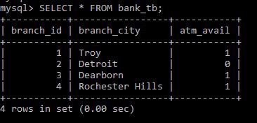SELECT * FROM bank_tb;

SELECT * FROM account_tb;

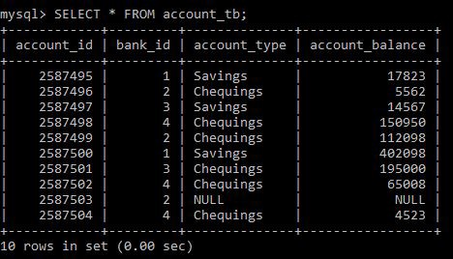

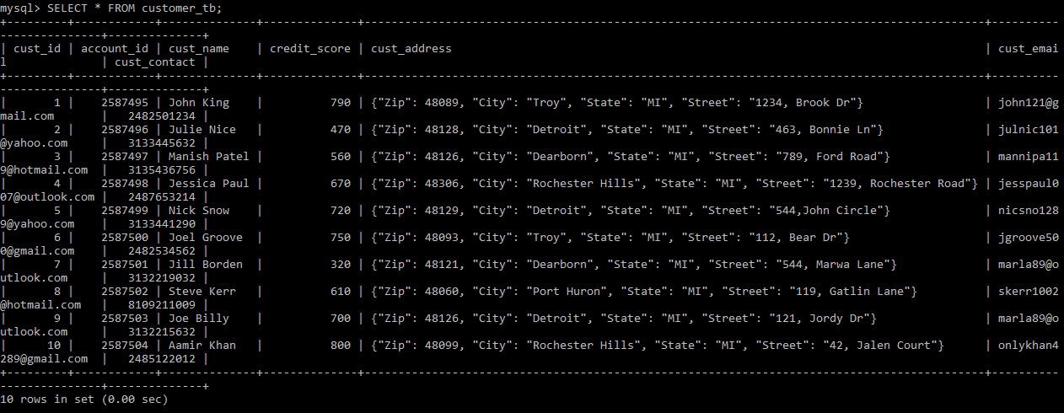SELECT * FROM customer_tb;

SELECT * FROM banker_tb;

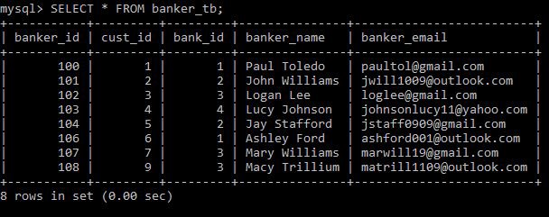

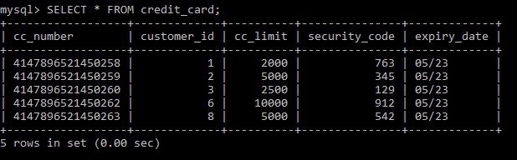SELECT * FROM credit_card;

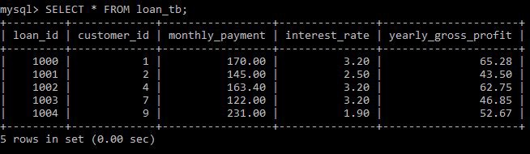SELECT * FROM loan_tb;

**6 .0 The SQL Statements - Loading Data**

DROP DATABASE IF EXISTS bank_db; CREATE DATABASE IF NOT EXISTS bank_db;

USE bank_db;

DROP TABLE IF EXISTS bank_tb; CREATE TABLE IF NOT EXISTS bank_tb(

branch_id INT(5) AUTO_INCREMENT, branch_city VARCHAR(15),

atm_avail BOOLEAN NOT NULL,

CONSTRAINT pk_branch_id PRIMARY KEY(branch_id)

);

DROP TABLE IF EXISTS account_tb; CREATE TABLE IF NOT EXISTS account_tb( account_id INT(7) AUTO_INCREMENT, bank_id INT(5) NOT NULL,

account_type ENUM('Savings','Chequings'), account_balance INT(11) DEFAULT 0,

CONSTRAINT pk_acc_id PRIMARY KEY(account_id),

CONSTRAINT fk_bank_id_account FOREIGN KEY(bank_id) REFERENCES bank_tb(branch_id)

)AUTO_INCREMENT=2587495;

DROP TABLE IF EXISTS customer_tb; CREATE TABLE IF NOT EXISTS customer_tb( cust_id INT(11) AUTO_INCREMENT,

account_id INT(7) NOT NULL, cust_name CHAR(35) NOT NULL, credit_score INT(11), cust_address JSON NOT NULL, cust_email VARCHAR(35),

cust_contact BIGINT(11) NOT NULL, CONSTRAINT pk_custid PRIMARY KEY(cust_id),

CONSTRAINT fk_accnt_id FOREIGN KEY(account_id) REFERENCES

account_tb(account_id)

);

DROP TABLE IF EXISTS banker_tb; CREATE TABLE IF NOT EXISTS banker_tb(

banker_id INT(3) AUTO_INCREMENT,

cust_id INT(11) NOT NULL, bank_id INT(5) NOT NULL,

banker_name CHAR(15) NOT NULL,

banker_email VARCHAR(35),

CONSTRAINT pk_banker_id PRIMARY KEY(banker_id),

CONSTRAINT fk_bank_id_banker FOREIGN KEY(bank_id) REFERENCES bank_tb(branch_id),

CONSTRAINT fk_cust_id_banker FOREIGN KEY(cust_id) REFERENCES

customer_tb(cust_id)

)AUTO_INCREMENT=100;

DROP TABLE IF EXISTS credit_card; CREATE TABLE IF NOT EXISTS credit_card( cc_number BIGINT(16) AUTO_INCREMENT,

customer_id INT(11) NOT NULL, cc_limit INT(4) NOT NULL, security_code INT(3),

expiry_date VARCHAR(5) DEFAULT "05/23", CONSTRAINT pk_cc_num PRIMARY KEY(cc_number),

CONSTRAINT fk_cc_cus_id FOREIGN KEY(customer_id) REFERENCES customer_tb(cust_id)

)AUTO_INCREMENT=4147896521450258;

DROP TABLE IF EXISTS loan_tb; CREATE TABLE IF NOT EXISTS loan_tb( loan_id INT(4) AUTO_INCREMENT,

customer_id INT(11) NOT NULL, monthly_payment DECIMAL(10,2) NOT NULL, interest_rate DECIMAL(10,2) NOT NULL,

yearly_gross_profit DECIMAL(10,2) GENERATED ALWAYS AS(12*(monthly_payment*interest_rate/100)) STORED, CONSTRAINT pk_loan_loan_id PRIMARY KEY(loan_id),

CONSTRAINT fk_loan_cus_id FOREIGN KEY(customer_id) REFERENCES customer_tb(cust_id)

)AUTO_INCREMENT=1000;

# 7 .0 The Query/Update results

##### Queries

#1 Bank customer's ID, Name and Zip code with high credit scores/No credit cards.

SELECT cust_id,cust_name,JSON_EXTRACT(cust_address,'$.Zip') AS 'Customers with no credit card'

FROM customer_tb

WHERE credit_score>=700 AND cust_id NOT IN (

SELECT customer_id FROM credit_card

);

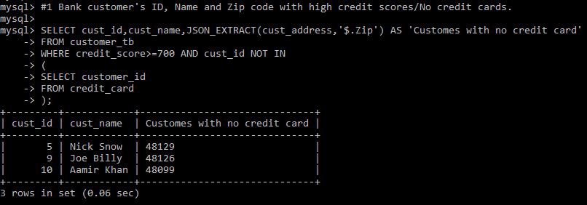

#2 Bank ID of Bank with the most credit card customers

SELECT CONCAT('Bank: ',bank_id,' has the maximum number of credit card customers, with ', COUNT(bank_id), ' customers') AS 'Banks with most credit card customers' FROM banker_tb

WHERE cust_id IN (

SELECT customer_id FROM credit_card

)GROUP BY bank_id LIMIT 1;

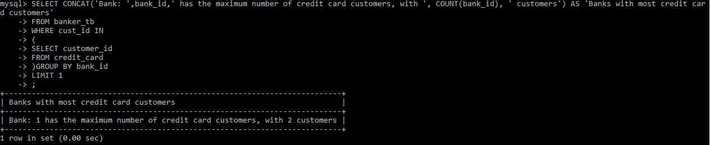

#3 ID, Name, Phone Number and Email of Bank customers with a high bank balance of 100k without a credit card.

SELECT at.account_id, ct.cust_name,ct.cust_contact,ct.cust_email FROM customer_tb ct

LEFT JOIN credit_card cc ON cc.customer_id=ct.cust_id

JOIN account_tb at ON ct.account_id=at.account_id WHERE cc.customer_id IS NULL

AND at.account_balance >= 100000;

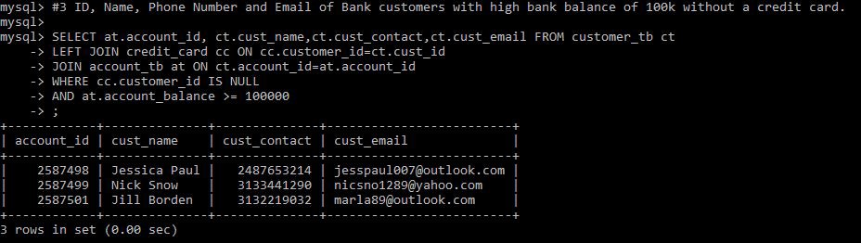

#4 Customer's ID, Phone number with credit cards but without the account type.

SELECT at.account_id, ct.cust_contact AS 'Phone Number', ct.cust_name FROM account_tb at

JOIN customer_tb ct ON ct.account_id=at.account_id RIGHT JOIN loan_tb lt ON lt.customer_id=ct.cust_id WHERE at.account_type IS NULL;

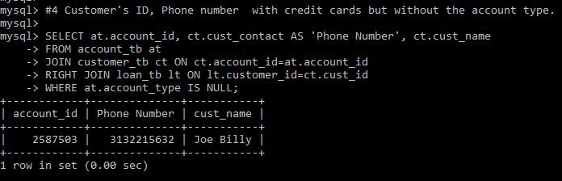

#5 Customer's Name, Email, Account ID, Account Balance, Credit card limit with high credit card limit equal or higher than 5k, with a bank balance of 50k or less.

SELECT ct.cust_name, ct.cust_email, at.account_id,at.account_balance, cc.cc_limit FROM customer_tb ct

JOIN credit_card cc ON cc.customer_id=ct.cust_id JOIN account_tb at ON ct.account_id=at.account_id

WHERE cc.cc_limit >= 5000 AND at.account_balance <= 50000;

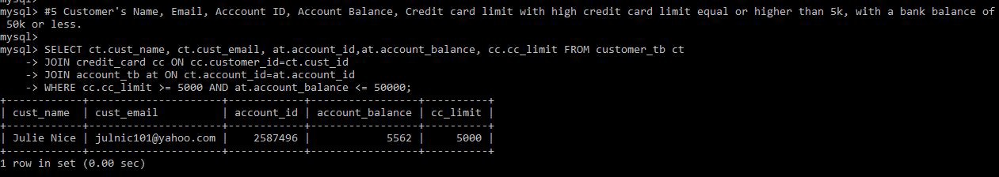

# 6 Customer's name, email, credit score and interest rate with high interest rate (3.0) and high credit score (700k or more).

SELECT ct.cust_name, ct.cust_email, ct.credit_score, lt.interest_rate FROM customer_tb ct

JOIN loan_tb lt ON lt.customer_id=ct.cust_id

WHERE ct.credit_score>= 700 AND lt.interest_rate>=3.0;

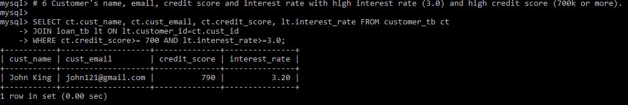

#7 Customers ID, Name, Email who don’t have a loan and have no credit card

SELECT ct.cust_id, ct.cust_name,ct.cust_email FROM customer_tb ct LEFT JOIN credit_card cc ON ct.cust_id=cc.customer_id

LEFT JOIN loan_tb lt ON ct.cust_id=lt.customer_id

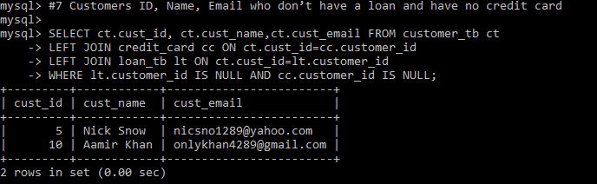WHERE lt.customer_id IS NULL AND cc.customer_id IS NULL;

#8 Banker name, id and email of the loan number 1002

SELECT banker_name, banker_id, banker_email FROM banker_tb WHERE cust_id IN

(

SELECT customer_id FROM loan_tb

WHERE loan_id = 1001

);

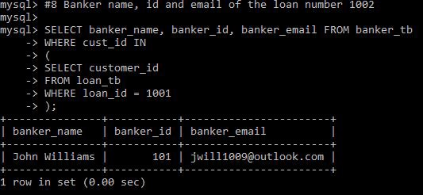

#9 Number of customers who bank in Troy and have a balance under 50k

SELECT count(cust_name) AS 'Num of customers', cust_name, cust_email FROM customer_tb

WHERE account_id IN

(

SELECT account_id FROM account_tb

WHERE account_balance <= 50000 AND bank_id IN (

SELECT branch_id FROM bank_tb

WHERE branch_city = "Troy"

)

);

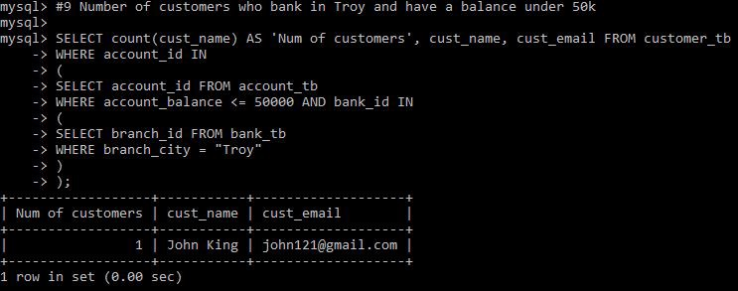

#10 Name, Phone number and email of customers who bank at a branch without an ATM with a high bank balance of 100k or more

SELECT cust_name, cust_contact, cust_email FROM customer_tb WHERE account_id IN

(

SELECT account_id FROM account_tb

WHERE account_balance <= 100000 AND bank_id IN (

SELECT branch_id FROM bank_tb

WHERE atm_avail = "False"

)

);

